Directions to Graham Carter & Co (Car Park)

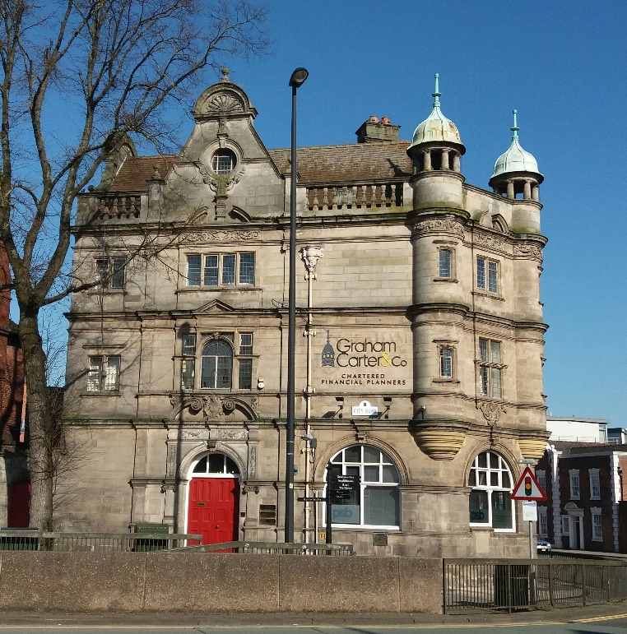

Graham Carter & Co
Old Bank Buildings
2 City Road
Chester
CH1 3AE

T: 01244 322722

Use Postcode CH1 3AE for Sat Nav directions
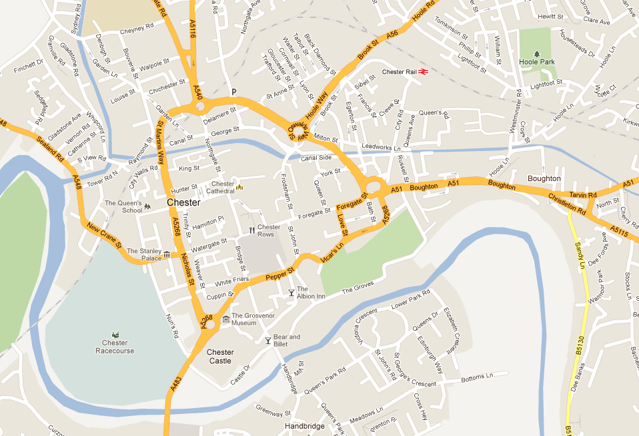
WE ARE HERE
Navigate to the gyratory system (large roundabout with offices on it) as shown on the map.
Graham Carter & Co is on the corner between City Road & Boughton Road (A51).

Turn off the roundabout into City Road, (Signposted Railway Station).

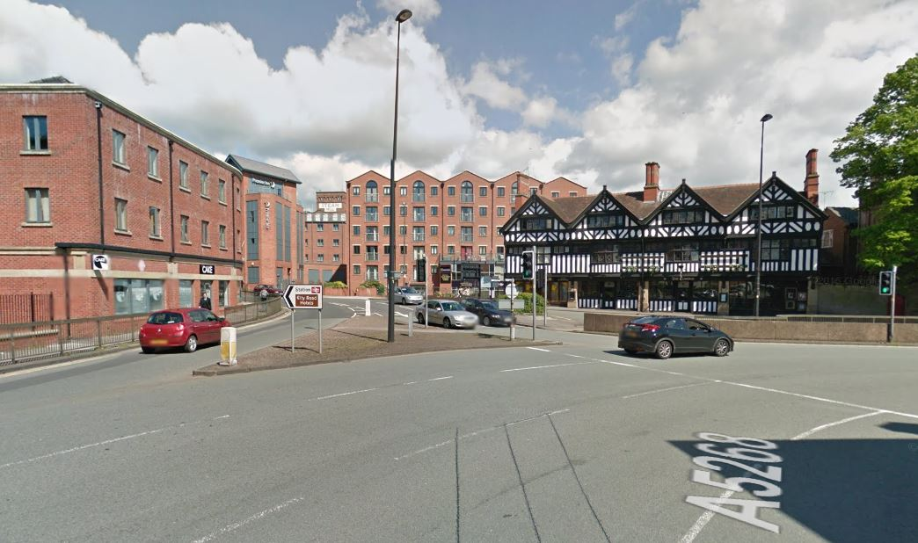

After 30 Metres take the 2nd right. Just after the phone box & in front of the Koconut Grove (Indian Restaurant) shown in the photo below.

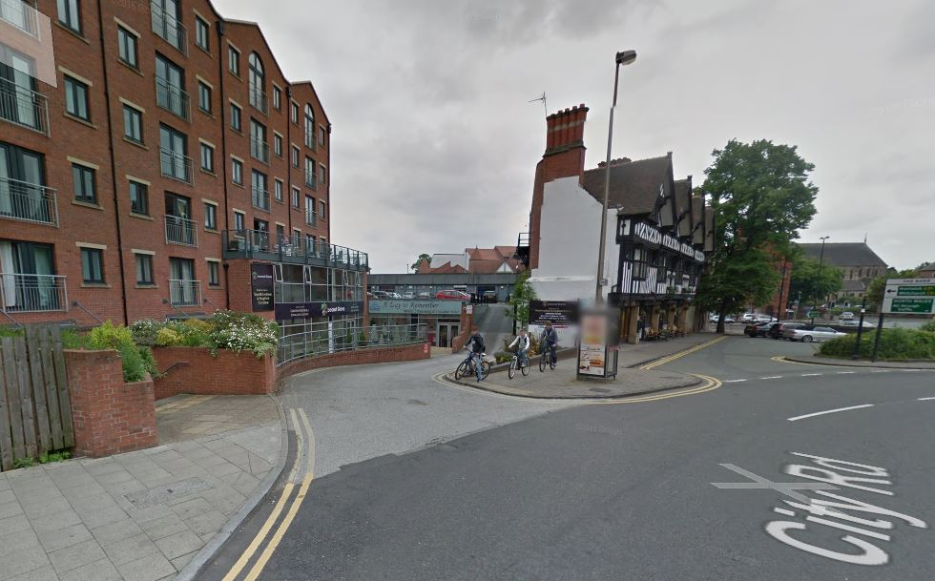

You will see a barrier in front of you and a raised drive leading to the car park. Call us on 01244 322722 and we will give you a code to key into the keypad to open the barrier.

On leaving the car park the barrier will automatically lift as you approach it.

If you have any problems finding us please don’t hesitate to call us on the above number.

Graham Carter & Co have two reserved car parking spaces these are indicated below.

